Name : K . Venkata Abhiram

Reg no : 192124154

**Day 3 Lab Manual Part 2**

**BIVARIATEANALYSIS IN R -COVARIANCE, CORRELATION, CROSSTAB**

**Exercise: 8**

Reference Status Gender TestNewOrFollowUp

1 KRXH Accepted Female Test1 New

2 KRPT Accepted Male Test1 New

3 FHRA Rejected Male Test2 New

4 CZKK Accepted Female Test3 New

5 CQTN Rejected Female Test1 New

6 PZXW Accepted Female Test4 Follow-up

7 SZRZ Rejected Male Test4 New

8 RMZE Rejected Female Test2 New

9 STNX Accepted Female Test3 New

10 TMDW Accepted Female Test1 New

1. Load the dataset and Create a data frame and name it as dataframe1

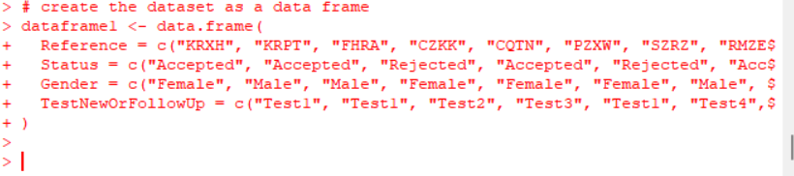

1. Load the function for crosstab

Note: Perform status+gender

|  |
| --- |
| Gender  Status Female Male  Accepted 5 1  Rejected 2 2  Note: Reference+Status  Status  Reference Accepted Rejected  CQTN 0 1  CZKK 1 0  FHRA 0 1  KRPT 1 0  KRXH 1 0  PZXW 1 0  RMZE 0 1  STNX 1 0  SZRZ 0 1  TMDW 1 0 |
|  |
| |  | | --- | |  | |

**Exercise: 9**

1. Use Two Categorical Variables and Discover the relationships within a dataset

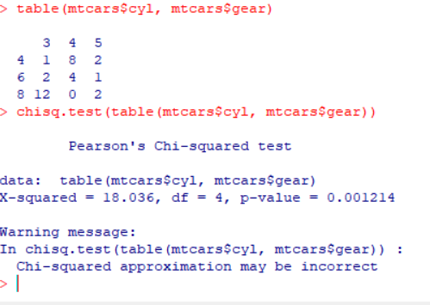

1. Next, using the xtabs() function, apply two variables from “dataframe1 “, to create a table delineating the relationship between the “Reference” category, and the “Status” category.

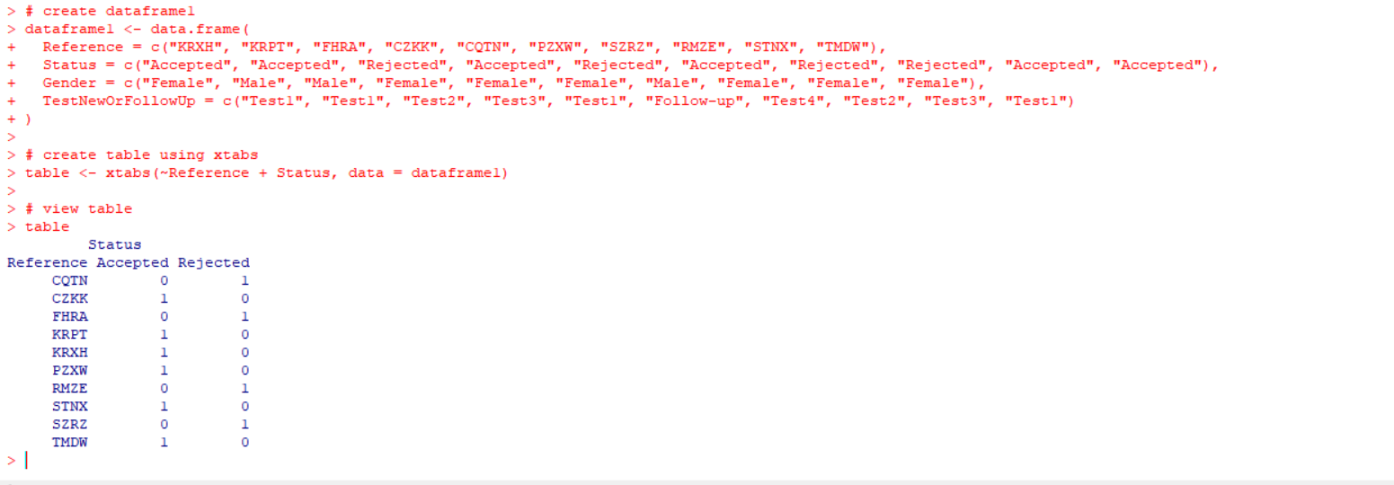

1. Save the file in the name of dataframe2

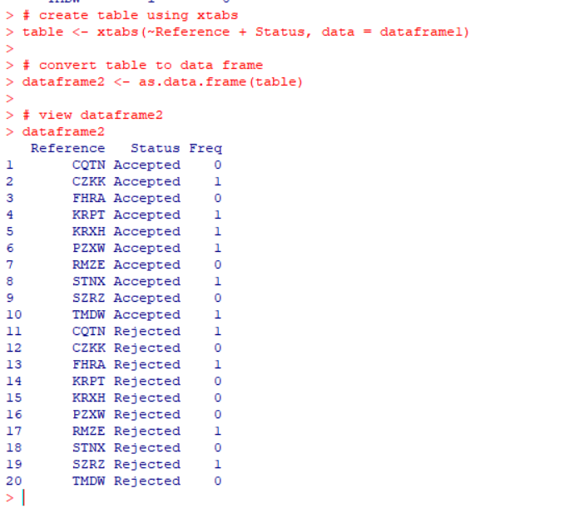

**Exercise: 10**

Use the same data frame using three Categorical Variables create a Multi-Dimensional Table

Apply three variables from “dataframe1” to create a Multi-Dimensional Cross-Tabulation of “Status“, “Gender“, and “Test“.

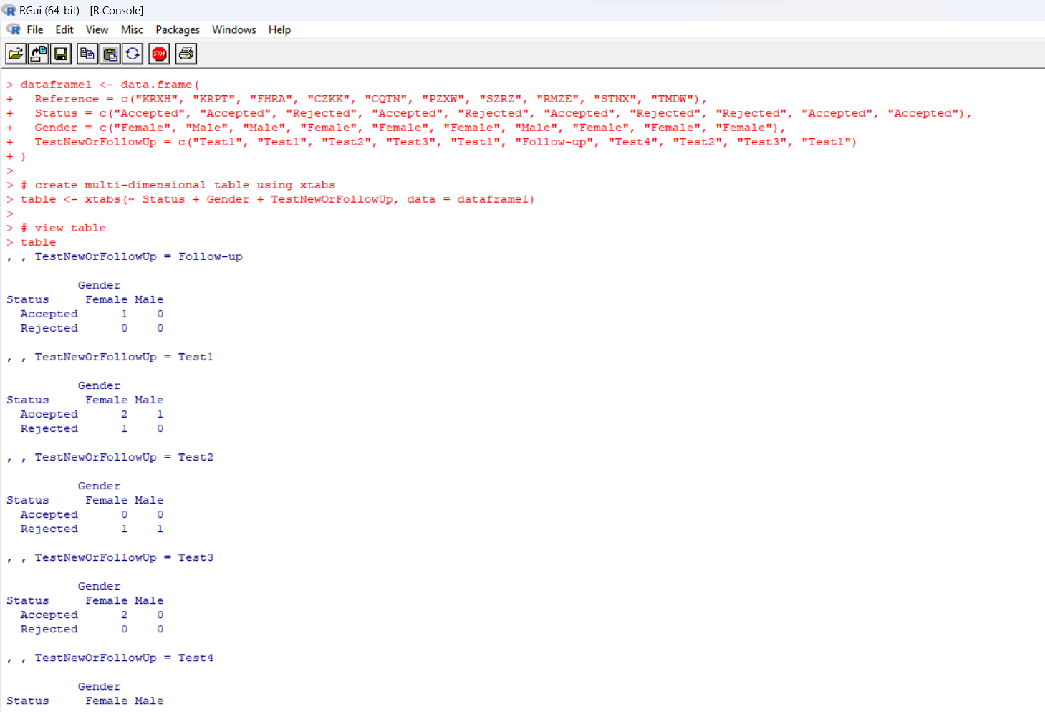

**Exercise: 11**

Row Percentages

The R package “tigerstats” is required for the next two exercises.

1. Create an xtabs() formula that cross-tabulates “Status“, and “Test“.

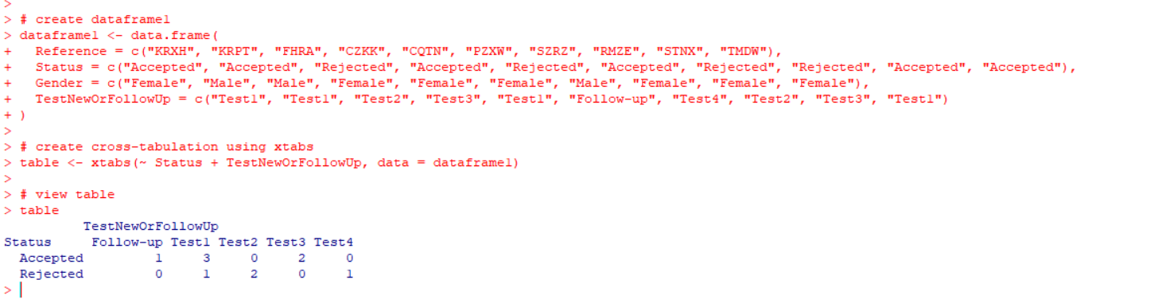

2) Enclose the xtabs() formula in the tigerstats function, “rowPerc()” to display row percentages for “Status” by “Test“.

**Exercise 12**

Column Percentages

1) Create an xtabs() formula that cross-tabulates “Status“, and “Test“.

2) Enclose the xtabs() formula in the tigerstats function, “colPerc()” to display row percentages for “Status” by “Test“.

**VISUALIZATION IN R**

1. Write a program for creating a pie-chart in R using the input vector(21,62,10,53). Provide labels for the chart as ‘London’, ‘New York’, ‘Singapore’, ‘Mumbai’. Add a title to the chart as ‘city pie-chart’ and add a legend at the top right corner of the chart.

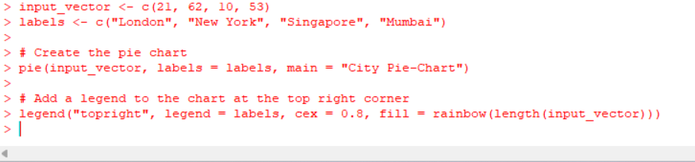

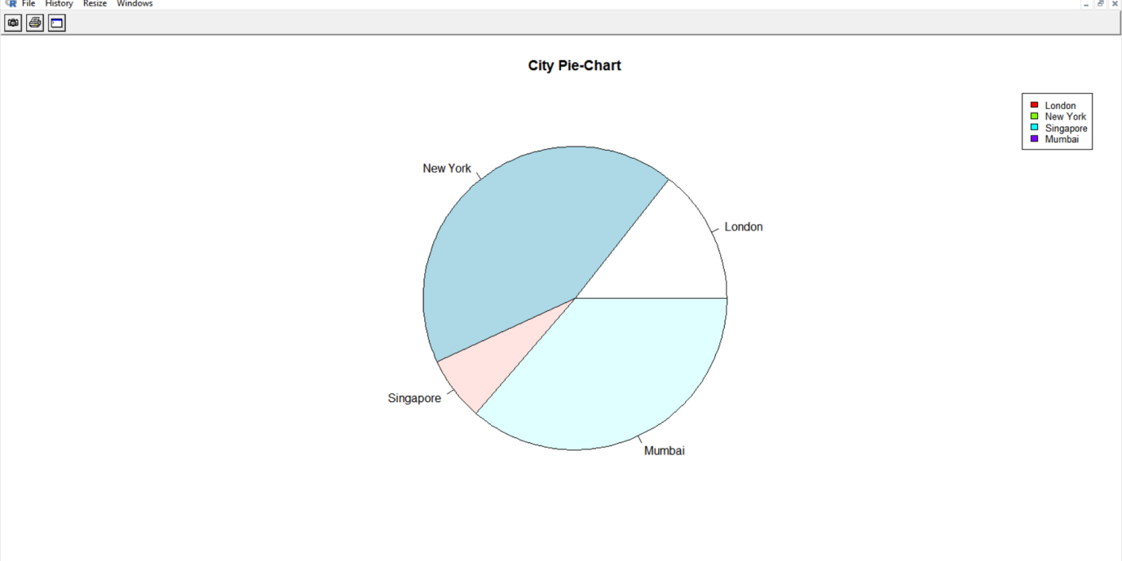

1. Create a 3D Pie Chart for the dataset “political Knowledge” with suitable labels,colours and a legend at the top right corner of the chart.
2. Write a program for creating a bar chart using the vectors H=c(7,12,28,3,41) and M=c(“mar”, “apr”, “may”, “jun”, “jul”). Add a title to the chart as “Revenue chart”.

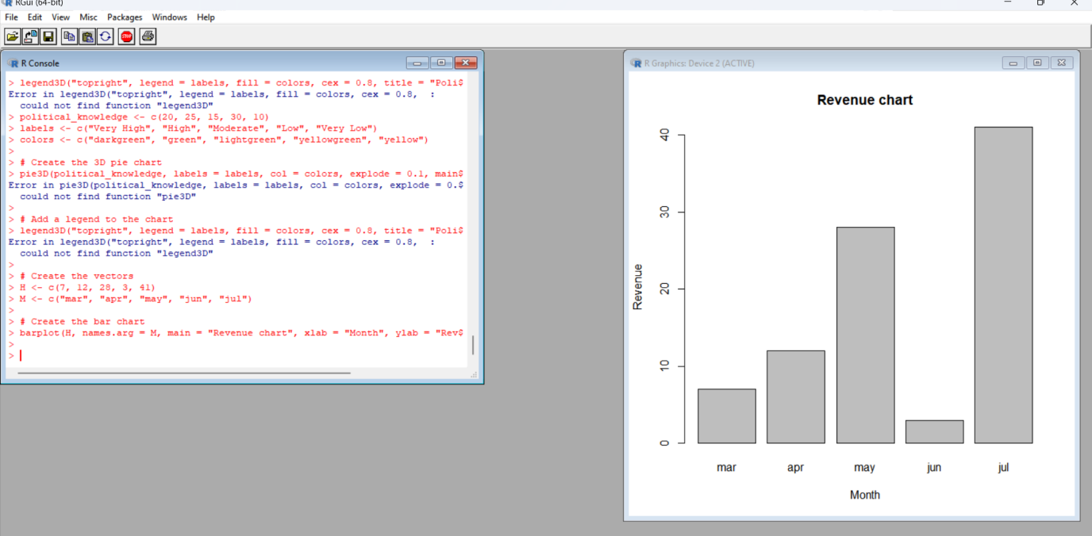

1. Make a histogram for the “AirPassengers“dataset, start at 100 on the x-axis, and from values 200 to 700, make the bins 200 wide

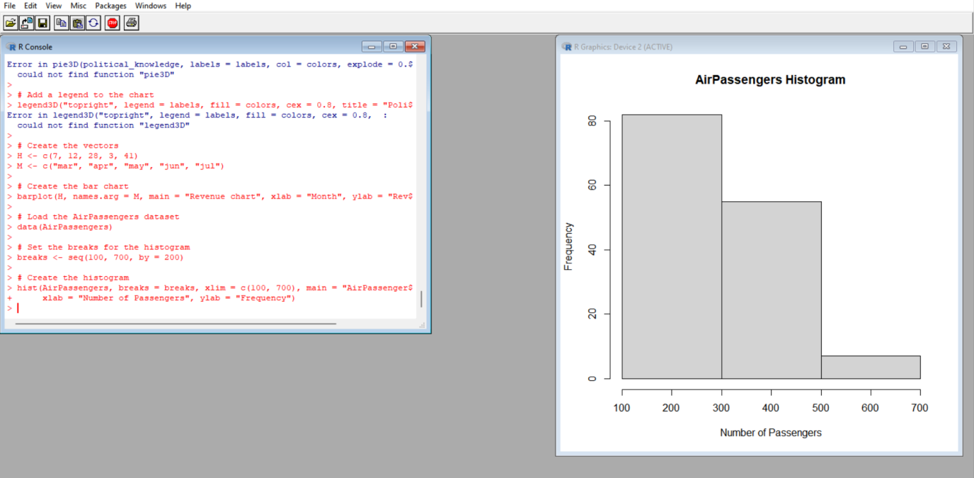

17Create a Boxplot graph for the relation between "mpg"(miles per galloon) and "cyl"(number of Cylinders) for the dataset "mtcars" available in R Environment.

